WEEK 2 : Consistent Eating / Protein

WEEKLY CHALLENGE: Eat 3 Balanced Meals per day (at least)
- Eat 3 specific meals spread evenly throughout the day.
- Balance your meals with Protein, Carbohydrates & Fats at EVERY meal
- Try to keep the meal size somewhat consistent (don’t eat all your cals in 1 meal)

BONUS CHALLENGE: Hit the Protein Goal for your bodyweight.
- For the Purposes of this week we are going to calculate this number as .75 grams per pound of body weight. (Take your realistically desired body weight and multiply it by .75)
- If you are looking to gain muscle or really take the challenge seriously, we recommend attempting to get in 1g of protein per pound of Body weight
- (each check mark here is worth half a point).

WEEKLY SCORE SHEET
(Sunday is a day “off” of the challenge but we still recommend you stick to the plan to get the best results on your follow up scan!)

 | MON | TUES | WED | THURS | FRI | SAT | TOTAL
DAILY  (1pt / ✔) |  |  |  |  |  |  | /6
BONUS  (.5 pt / ✔) |  |  |  |  |  |  | /3
AB  (3 ✔ = 3 pts)  (5 ✔ = 4 pts) |  |  |  |  |  |  | /4
MOBILITY  (2 ✔ = 1 pts)  (4 ✔ = 2 pts) |  |  |  |  |  |  | /2
TOTAL  WEEKLY  SCORE |  |  |  |  |  |  | /15
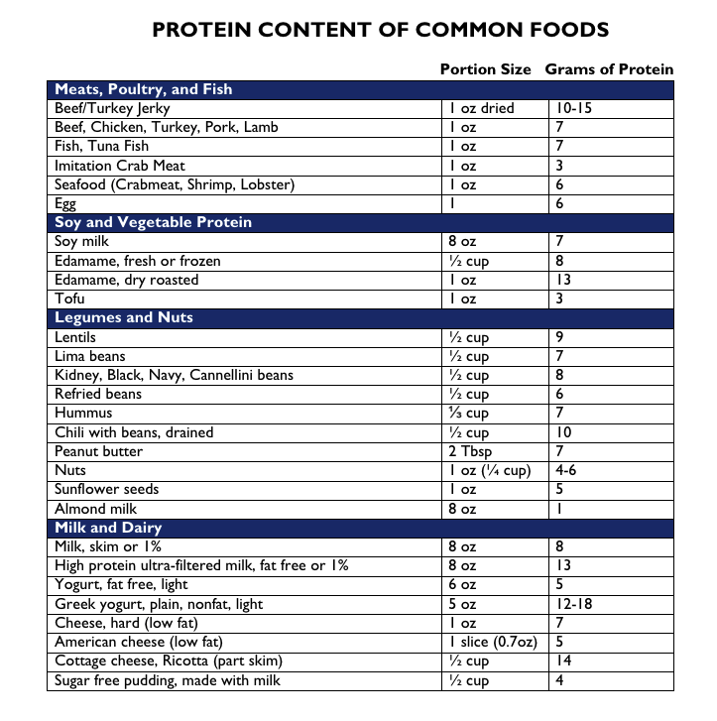

*A higher protein intake actually increases your levels of the satiety (appetite-reducing) hormones GLP-1, peptide YY, and cholecystokinin while reducing your levels of the hunger hormone ghrelin. If you replace some of the carbs and fat in your diet with protein, you may experience less hunger and feel greater satiety.

*Your body needs protein to stay healthy and work the way it should. More than 10,000 types are found in everything from your organs to your muscles and tissues to your bones, skin, and hair.

Protein is also a critical part of the processes that fuel your energy and carry oxygen throughout your body in your blood. It also helps make antibodies that fight off infections and illnesses and helps keep cells healthy and create new ones

Here are five compelling reasons why you should make sure you are getting enough protein every day:
- Build. Protein is an important building block of bones, muscles, cartilage and skin. In fact, your hair and nails are comprised mostly of protein.
- Repair. Your body uses it to build and repair tissue.
- Oxygenate. Red blood cells contain a protein compound that carries oxygen throughout the body. This helps supply your entire body with the nutrients it needs.
- Digest. About half the dietary protein that you consume each day goes into making enzymes, which aids in digesting food, and making new cells and body chemicals.
- Regulate. Protein plays an important role in hormone regulation, especially during the transformation and development of cells during puberty.

